PROCEDURE :-

**Step 1 :** Login Nagios.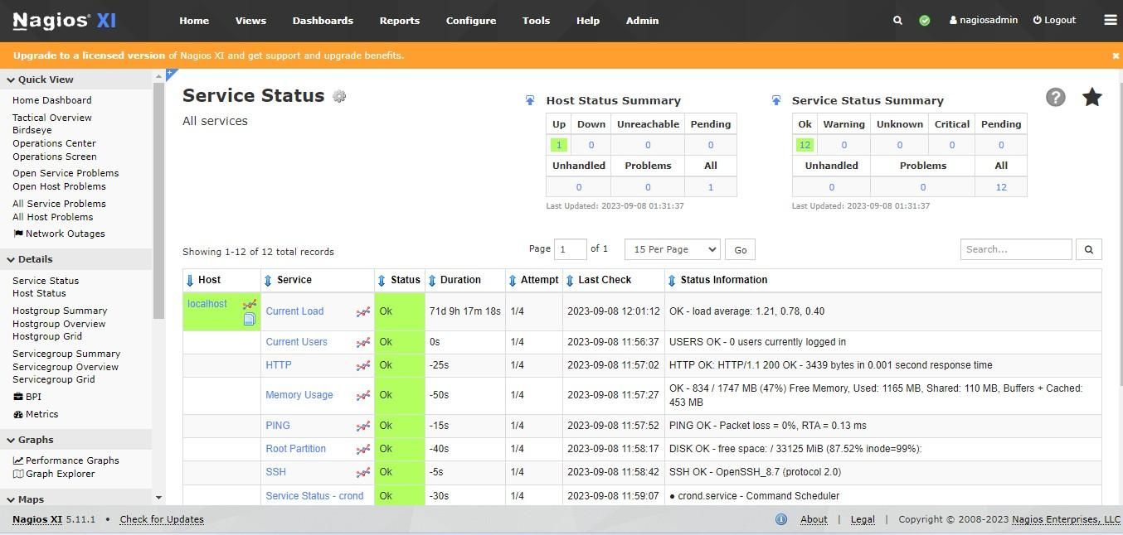

**Step 2 :** Go to Configuration Options and click on Start Monitoring Now.

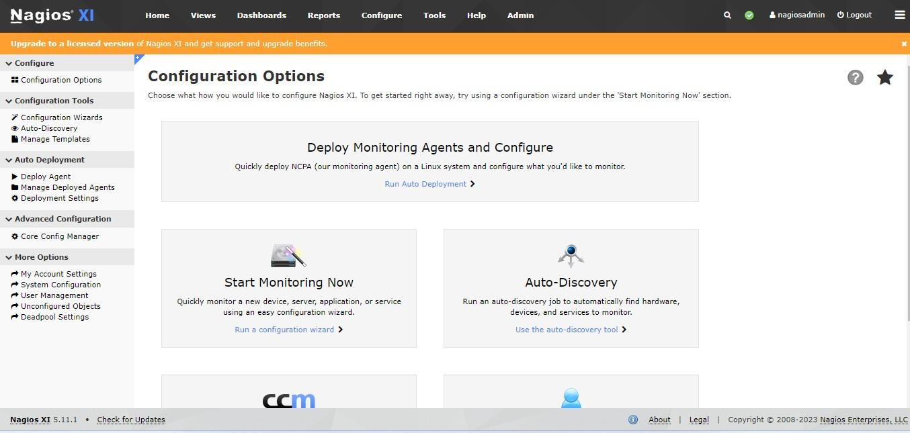

**Step 3 :** Click on Amazon EC2 wizard.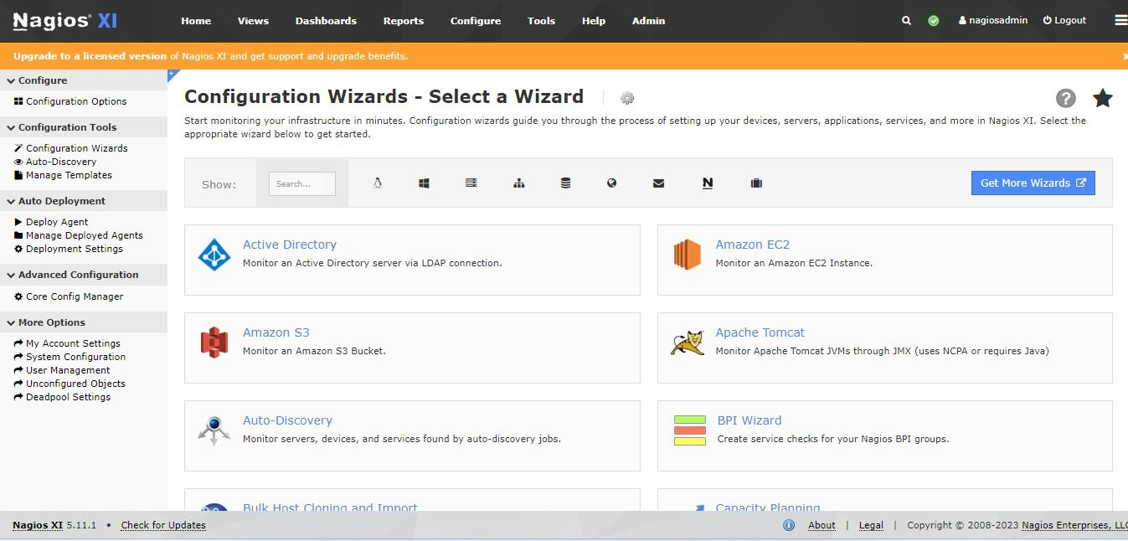

**Step 4 :** Add the Access Key ID & Secret Access Key and click Next.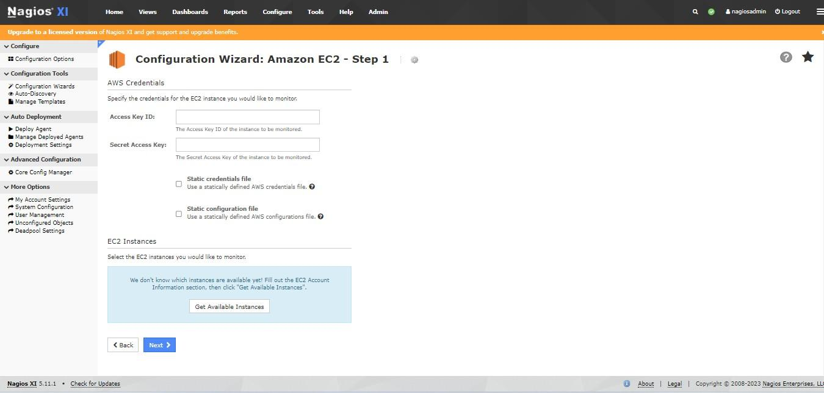

**Step 5 :** Your instance ID is available now.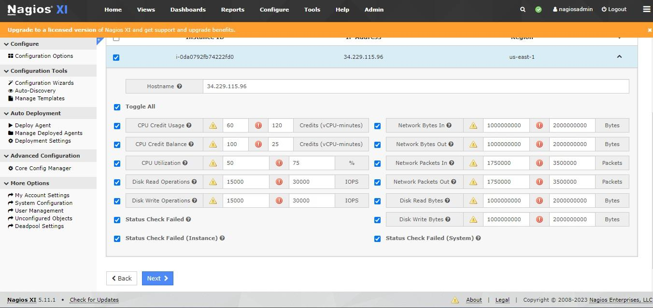

**Step 6 :** Click on Next & Finish.

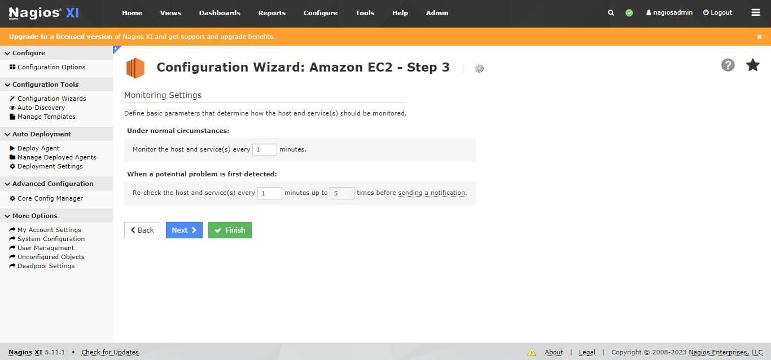

**Step 7 :** Now, Amazon EC2 Monitoring wizard configuration is applied successfully.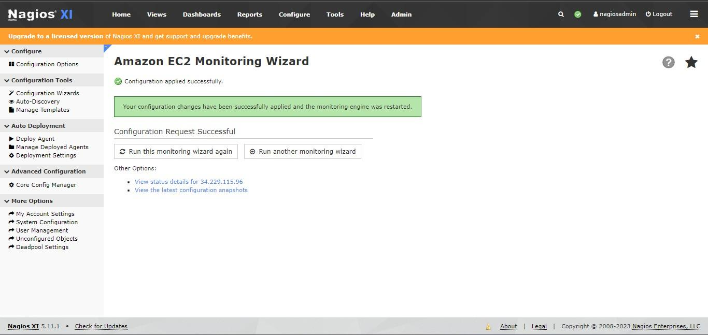

**Step 8 :** Now, check your host status details in Services.



**Step 9** : Now, go to Configuration Options and click on Start Monitoring Now.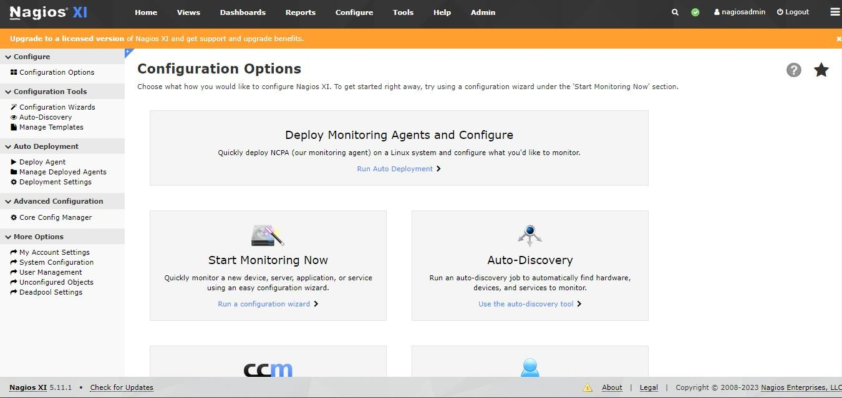

**Step 10 :** Click on Website URL wizard.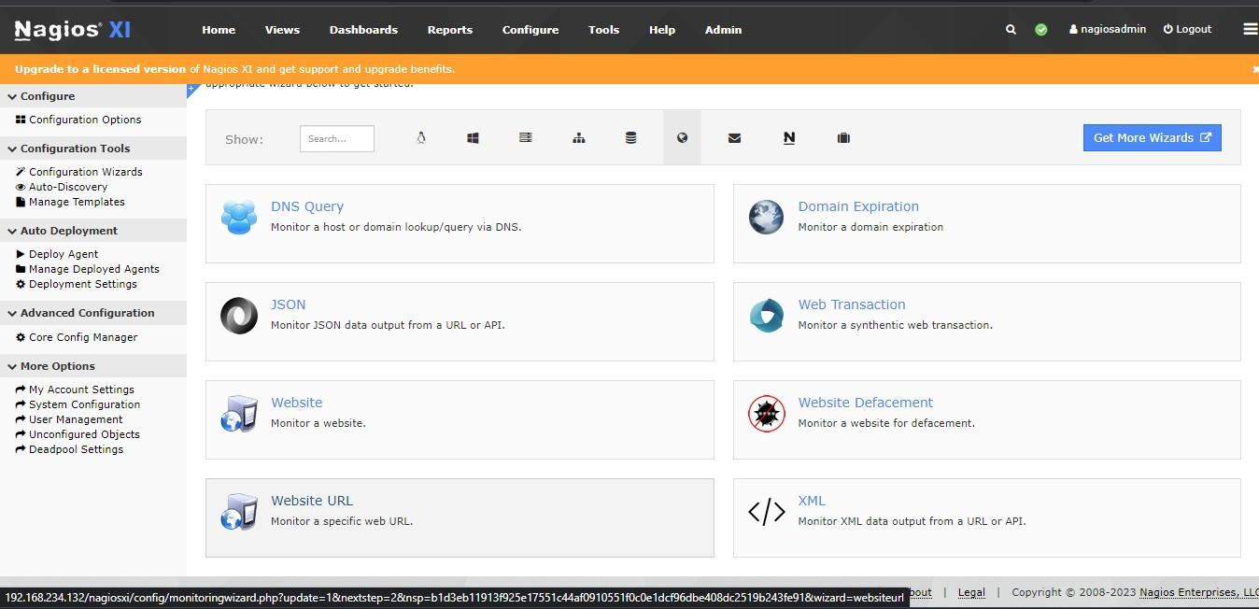

**Step 11 :** Now, enter the URL for configuration and click Next.

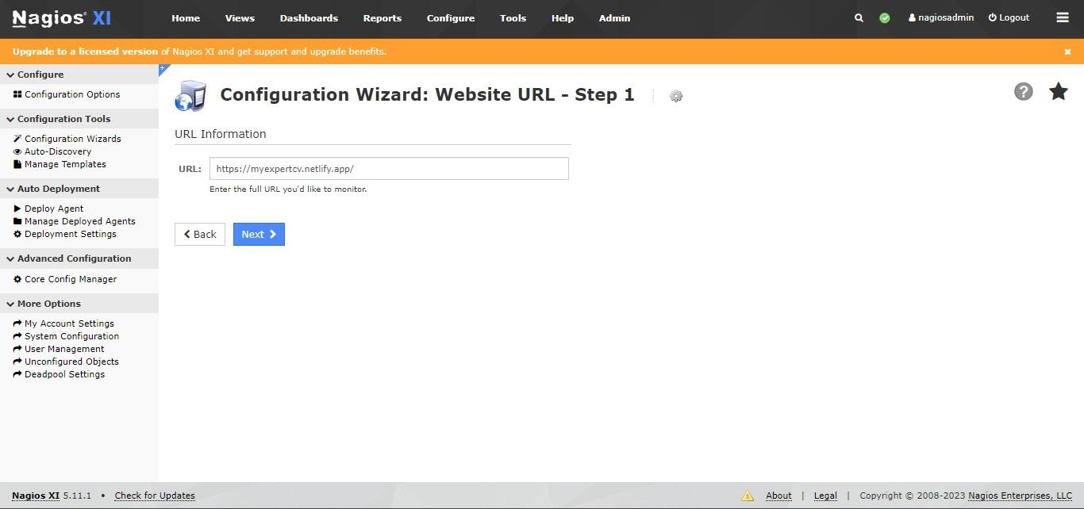

**Step 12** : Click on Next.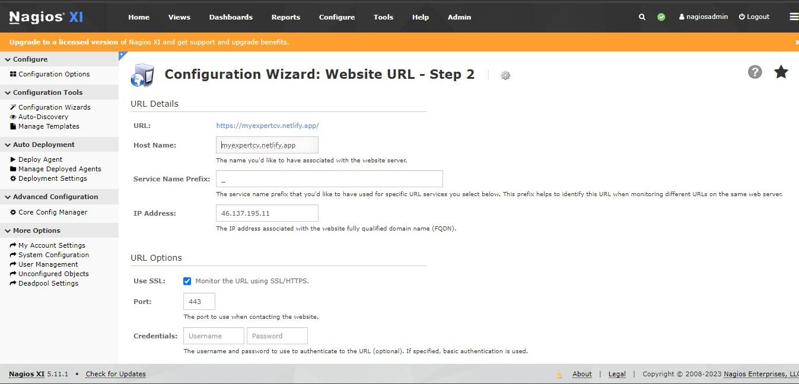

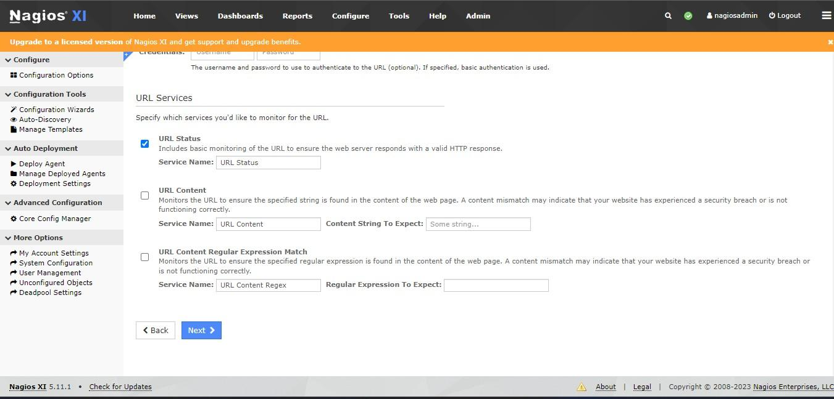

**Step 13** : Click on Next & Finish.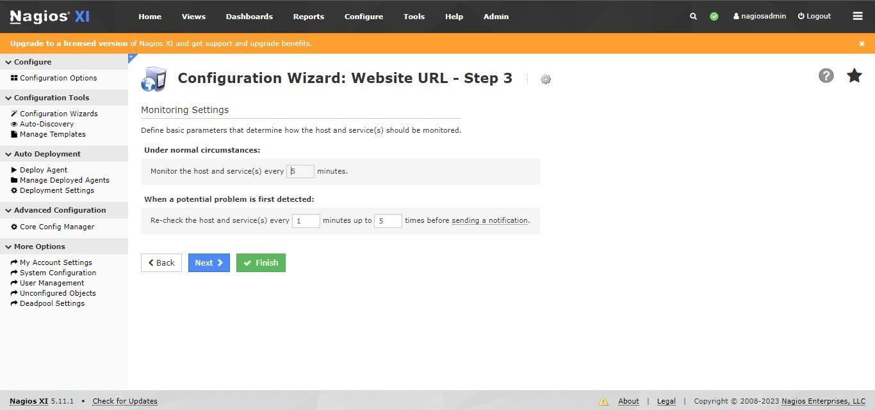

**Step 14** : Now, Website URL Monitoring wizard configuration is applied successfully.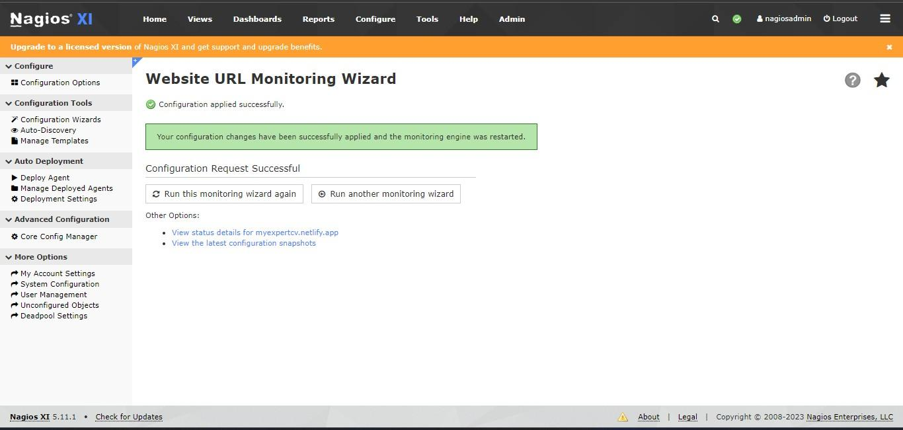

**Step 15 :** Now, you can check your host URL status.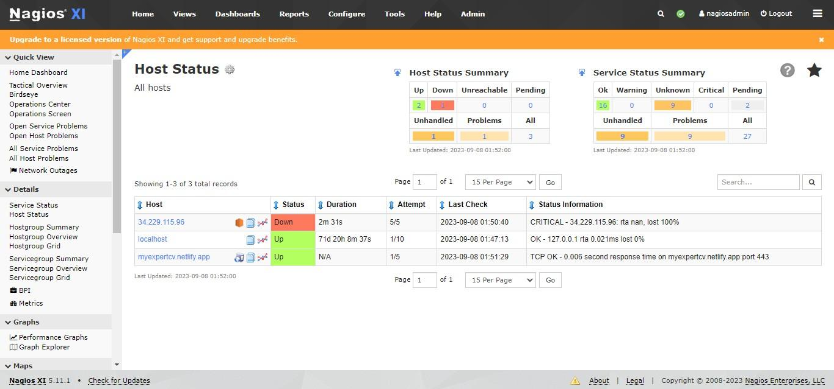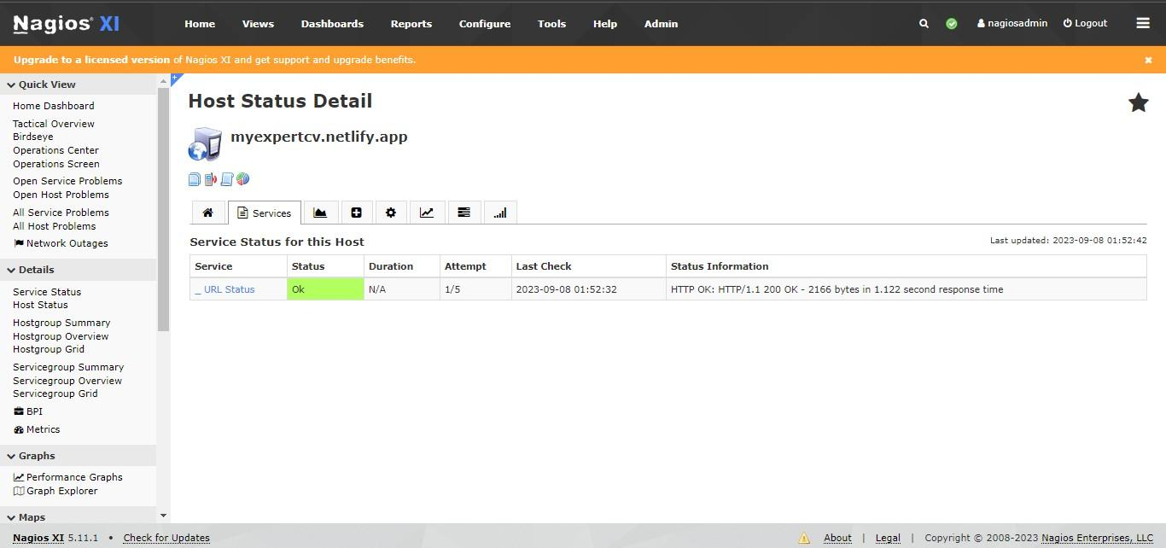

**Step 16 :** Now, download NSClient++ inorder to monitor it.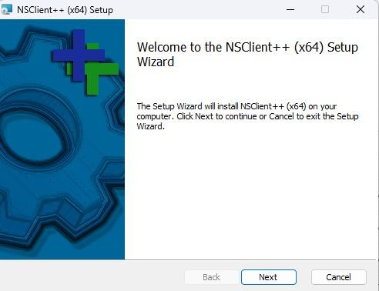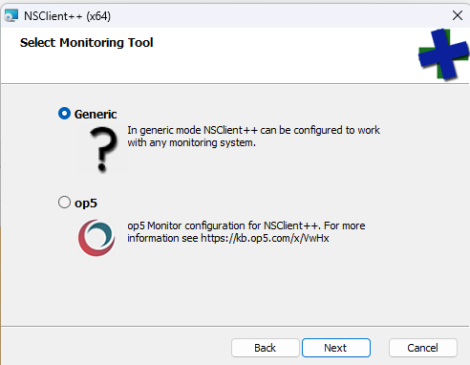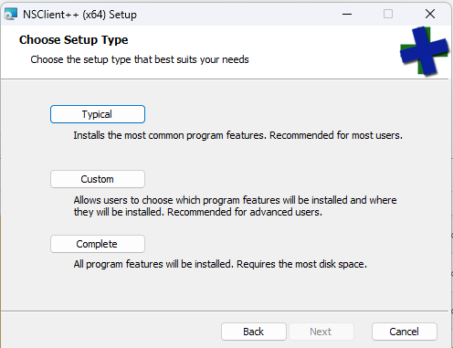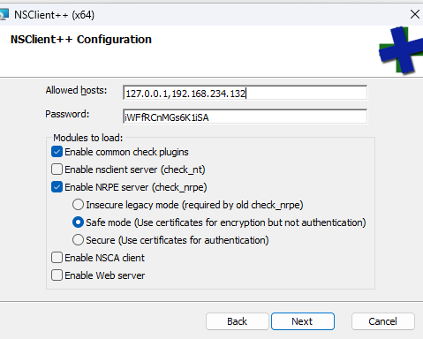

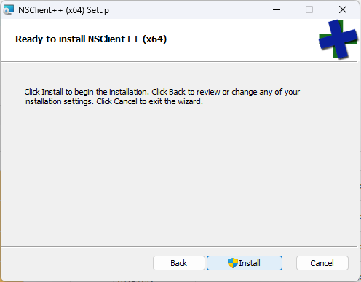

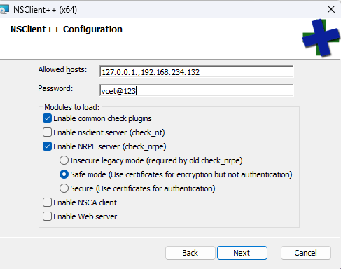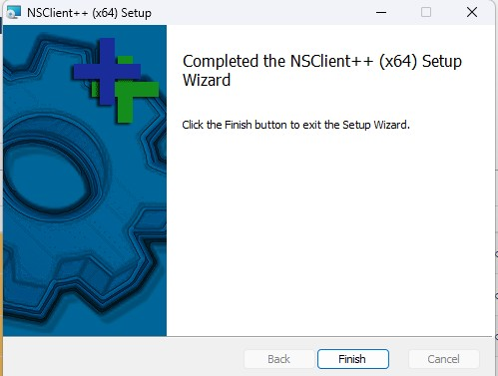

**Step 17 :** Now, go to Configuration Options and click on Start Monitoring Now.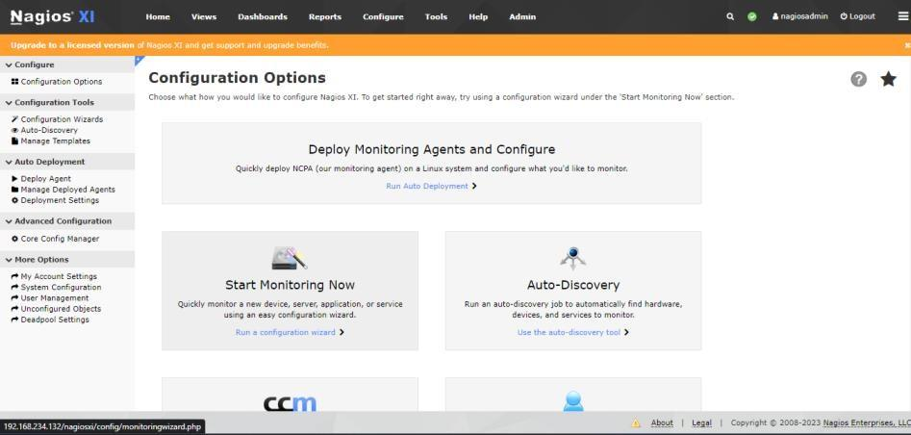

**Step 18 :** Click on NSClient++ wizard.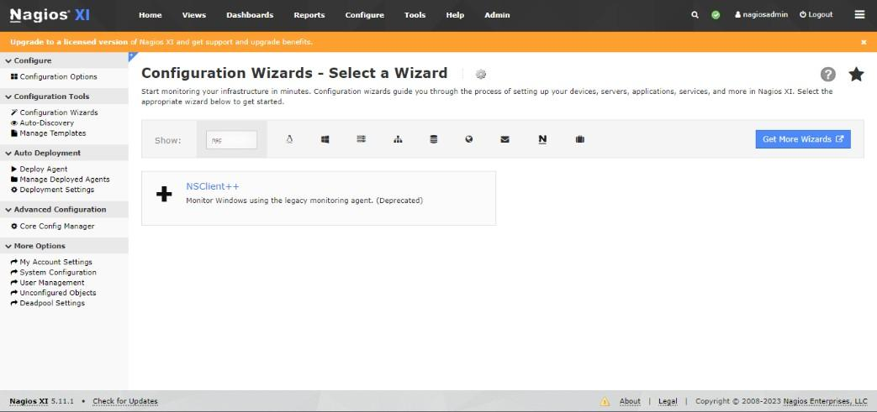

**Step 19 :** Click Next.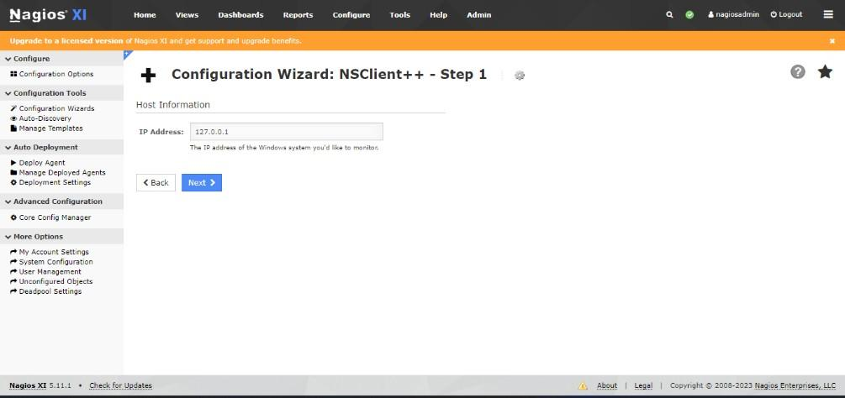

**Step 20 :** Now, click Next.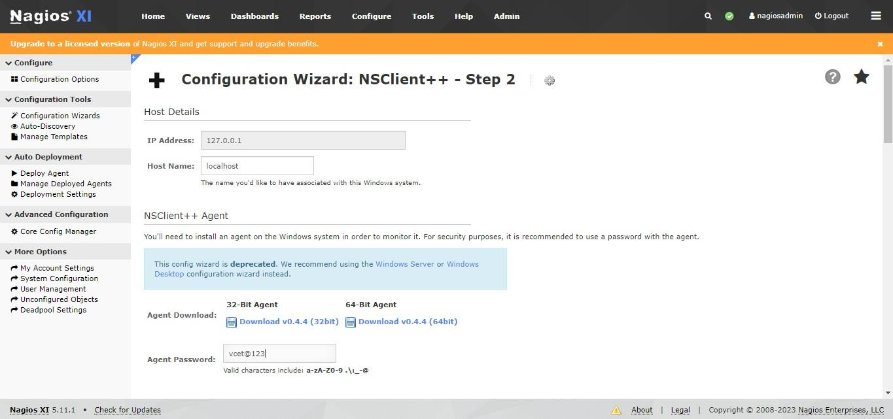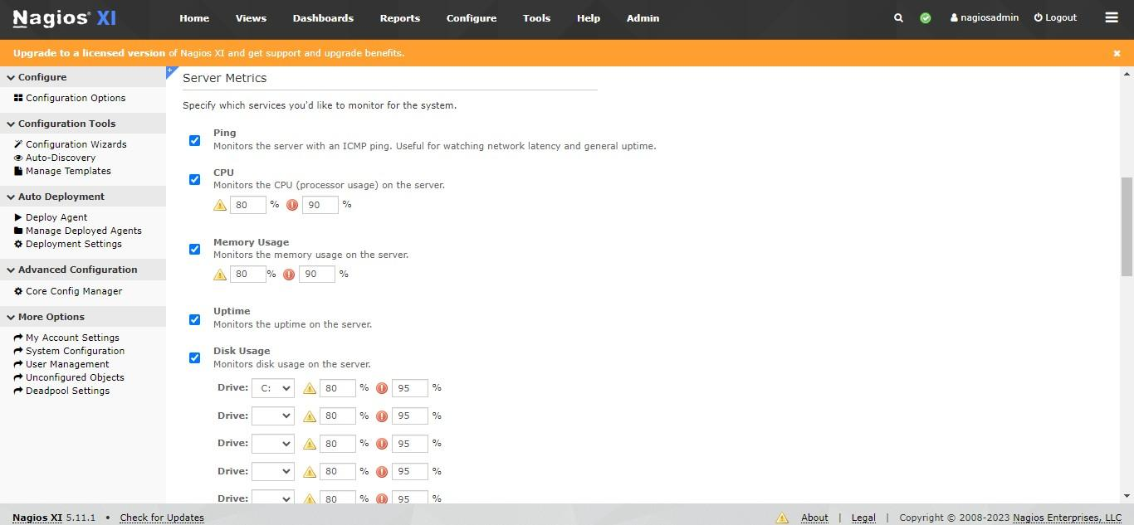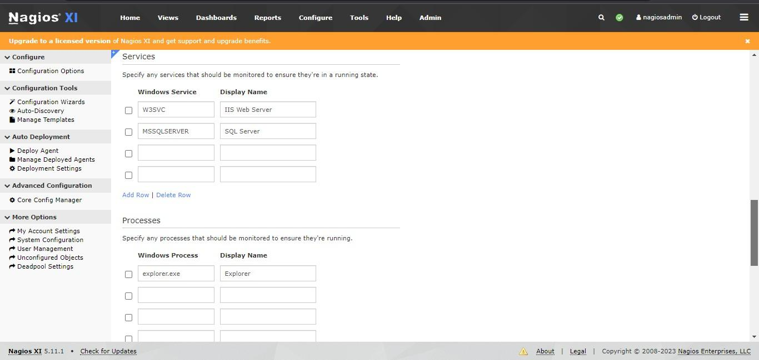

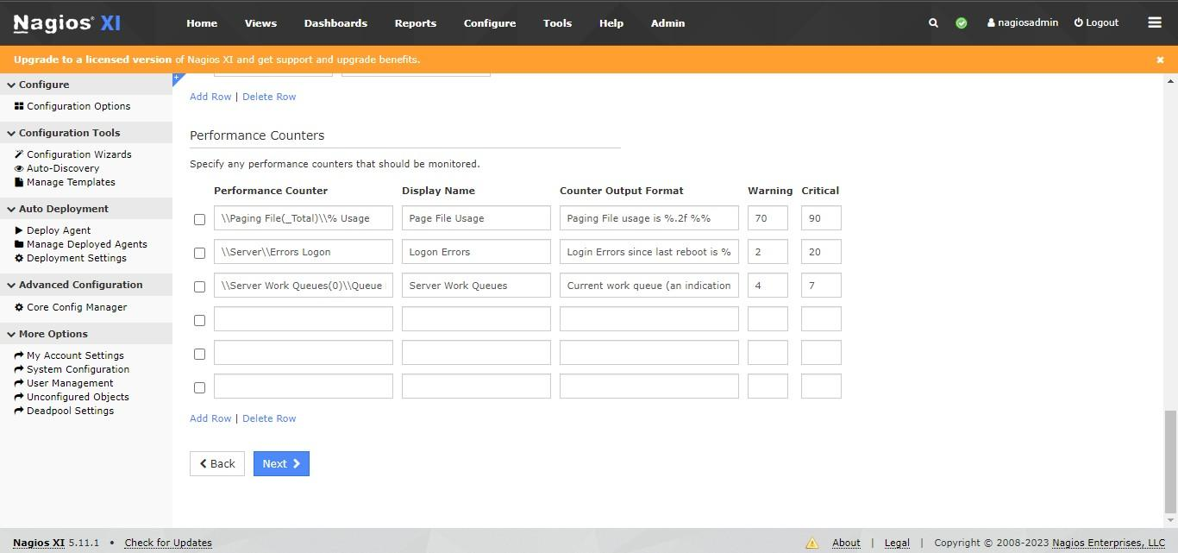

**Step 21 :** Now, Click on Next & Finish.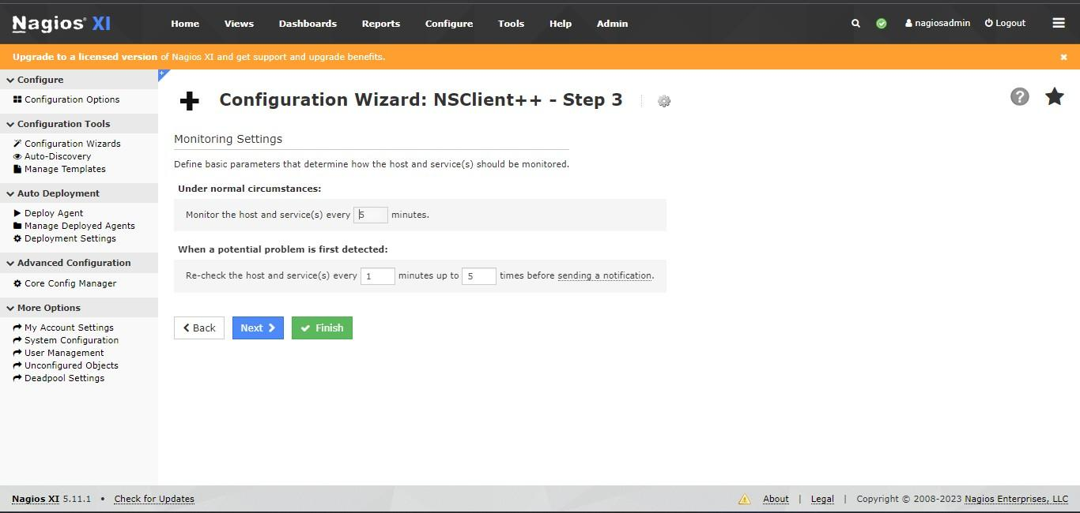

**Step 22 :** Now, NSClient++ Monitoring wizard configuration is applied successfully.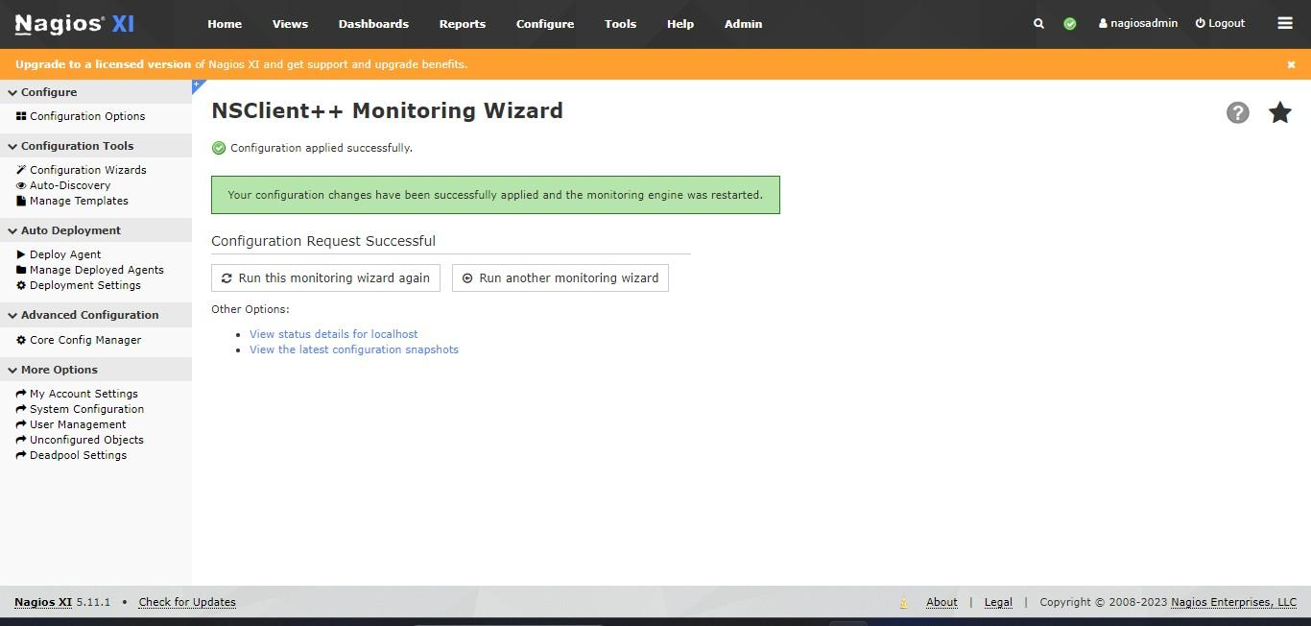

**Step 23 :** Now, you can check your host service status for continuous monitoring view.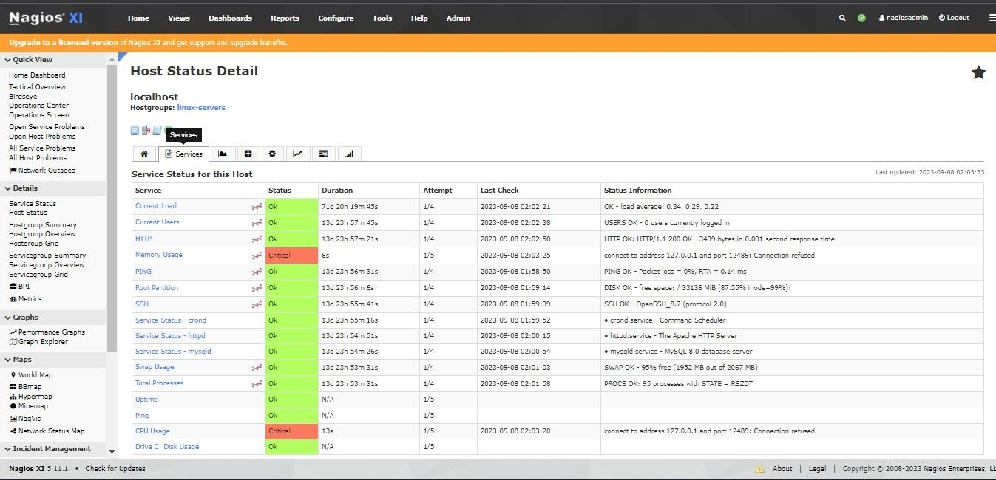

**Conclusion :-**